

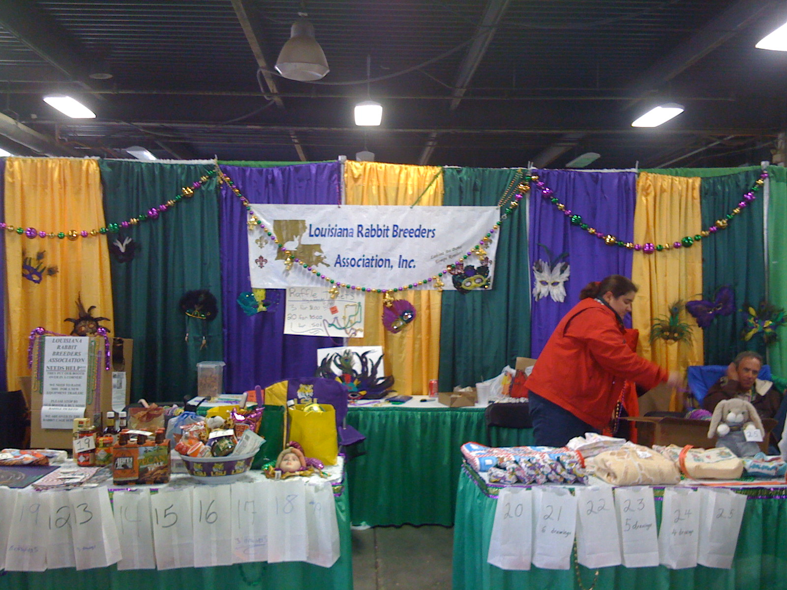

LRBA Booth at Convention in Kentucky

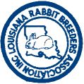

Inside – Biographies of Award Nominees,
and more.......

LOUISIANA RABBIT BREEDERS ASSN., INC.
OFFICERS

PRESIDENT – Lynn Hebert
633 Resweber St, St. Martinville LA 70582-4749
337-394-6779
HEBELY00@aol.com

VICE-PRESIDENT-Gwen Himel
12304 Beco Road, St. Amant, LA 70774
225-647-1723
gwenhimel@yahoo.com

SECRETARY- Tracy Saunier
P.O. Box 478, Delcambre, LA 70528
337-517-8159
Little_hoppers@excite.com

TREASURER – Lori Neagle
100 Baker St, Broussard LA 70518
337-303-2132
LNeagle@hotmail.com

SWEEPTAKES - OPEN - YOUTH
Kevin LeBlanc
2248 Riverside Drive, Port Allen, LA 70767
225-749-8659
kmlebla@cox.net

NEXT NEWSLETTER DEADLINE:
January 31, 2009

LRBA, Inc. web page
http://www.louisianarba.com
LRBA Email List
www.yahoogroups.com - Join group labeled LRBA

NEWSLETTER ADVERTISING RATES
business card ad $4.00 per year
¼ page ad $4.00 per issue
½ page ad $6.00 per issue
full page ad $10.00 per issue
Ad copy & payment should be mailed to LOUISIANA RABBIT BREEDERS ASSN., INC.,
Lori Neagle
100 Baker St, Broussard LA 70518
337.303.2132
LNeagle@hotmail.com
by published deadline
LOUISIANA RABBIT BREEDERS ASSN., INC.
BOARD OF DIRECTORS
Lori Neagle
100 Baker St, Broussard LA 70518
337.303.2132
LNeagle@hotmail.com
CHAIRMAN

SECRETARY
Gwen Himel
ACADIANA AREA RABBIT CLUB
Molly Frank & Yvonne Hebert
ARK/LA/TEX RABBIT CLUB
Sherry & Steve Patton
BONNE TERRE RABBIT ASSN.
Al Boudreaux & Sonia Lirette
BONNE TERRE YOUTH RABBIT CLUB
Lane Lirette & Melody Loupe
CAJUN CAVY CLUB
Tracey Freeman & Lance Gendron
CENTRAL LOUISIANA RABBIT BREEDERS
Karen King Guillory & Colette Waters
MAGNOLIA STATE RABBIT BREEDERS ASSN.
Mary Ellen & Ronnie Hopson
MID-SOUTH NETHERLAND DWARF RABBIT CLUB
Dale Anne Dupre & Carol Petitjean
TRI PARISH DUTCH CLUB
Jimmie Daniel & Gwen Himel
LRBA PRESIDENT
Lynn Hebert
LRBA VICE-PRESIDENT
Gwen Himel
LRBA SECRETARY
Tracy Saunier

LOUISIANA RABBIT BREEDERS ASSN., INC.
YOUTH ADVISORY BOARD
CHAIRMAN
Mechele Williams
830 Forest Camp, Simsboro, LA 71275
318-263-3887
Chele629@yahoo.com

Liane Baird – Tri-Parish Dutch Rabbit Club
Dale Anne Dupre’– Acadiana Area Rabbit Club
– Bonne Terre Youth Rabbit Club
J L Dino – member
Tracey Freeman – Magnolia State Rabbit Breeders Assn.
Lynn Hebert - member
Gwen Himel - member
Christine Katz – Bonne Terre Rabbit Assn.
Lori Neagle - Secretary
Teresa Gilmore – Central Louisiana Rabbit Breeders Assn.
Mechele Williams – Ark/LA/Tex Rabbit Club Shari Zeringue–Mid-South Netherland Dwarf Rabbit Club

From the desk of the LRBA President

As I am writing this article our 2008-2009 show season is just getting started. Central Louisiana Rabbit Breeders Association has held the first show of the season. They had a larger number of entries than they have had in years. Many had feared that the number of rabbits exhibited may have dropped off some with the strain of the two hurricanes, high gasoline prices and the weak economy. This is encouraging and I hope we will continue to see a large number of rabbits exhibited throughout the season.

Several of our club members made the trip up to Louisville, Kentucky to the 85th ARBA Annual Convention and Show. I believe that everyone from Louisiana had a grand time. Congratulations to all who exhibited and to those who placed.

Please take the time to read the profiles of the members nominated for LRBA awards and to cast your vote for the ones you feel deserve these awards. Remember that your ballot must be postmarked by December 31st for your votes to be counted.

I would like to take a moment to encourage each club to send in an article to our newsletter editor for each newsletter. In this article they should tell the rest of us what their club is doing. By promoting your activities you will boost membership numbers and attendance at your clubs’ events. This is not a new idea. A few years ago all of the local clubs sent in articles to be published in the newsletter. I think this was a good practice that we need to start following again.

May God bless you all.

Lynn Hebert
LRBA President

PURINA WEIGHT CIRCLES
Turn your weight circles in to Cory Patton. The money that we collect from these goes to the Scholarship Show

From the Vice-President
Hi Everyone,

I would like to start by letting you all know that we had a great time at the Convention in Louisville. Many of our LRBA folks placed well. I would like to say congratulations to them all. I learned many new things as usual. It was great to see all of our old friends and to make many new friends.

The trip was a wonderful experience though the first day was marked by great sadness. Eric and I were very sad to hear of the passing of one of our rabbit family. We would like t o express our deepest sympathy to the Cormier family. Our thoughts and prayers are with you all. We continue to pray for Mr. Butch every day.

I would also like to remind all of you to submit your votes for the annual awards. Having won one of the awards myself, I know it is an honor. Please bestow this honor on our nominees by voting for your choice. I would like to remind you that you can vote for 2 nominees for Hall of Fame.

The first 2 shows this year have been great successes. I hope this continues and I look forward to seeing all of you at the shows.

Hoppy Day to you,
Gwen Himel
Vice-President LRBA

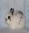TNT’s Country Critters
Jersey Wooly Rabbits
Agouti, Broken, Self, Shaded

Tracey & Tyrone Freeman
125 TNT’s Place, Bogalusa, LA 70427
(985) 732-5060

Web: www.tntsjerseywoolies.com
Email: tntscountrycritters@hotmail.com

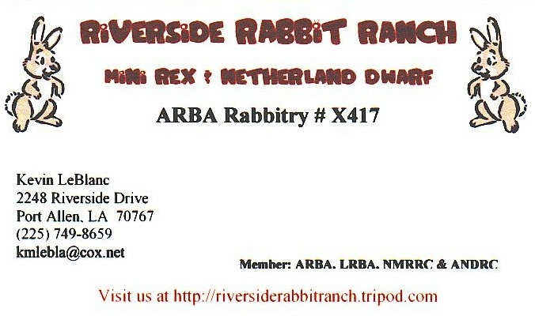


Bruce & Sheila Spillers Sheila Spillers & Jeff Taylor, Sr.
Ruston, LA Ruston & Ferriday, LA

Quality Satins & Red Wigglers Skirting & More!

Will ship worms in fall & spring Mobile Home Repairs & Service (318)251-2442 (318) 235-5672 (318) 719-1878 (318) 278-3632
I would like to encourage all secretaries of the local and specialty clubs in our state to please send reports of what’s going on in y’all clubs so we can put them in the LBRA newsletter…it may encourage added members and it will keep us closer to each other through the upcoming season.



LAYA RABBITRY
Specializing in
GRAY & TORT
DUTCH
Lynn & Yvonne Hebert
633 Resweber Street
St. Martinville, LA 70582-4749
(337) 394-6679
HEBELYOO@aol.com
EVONABEAR@aol.com

Award Nominee Biographies

Hall of Fame

Lynn Hebert

Hello!

I am 52 years old and have been happily married to my wife Yvonne for 34 years. My wife and I have 4 children, ranging in age from 25 to 33. I have been a member of the LRBA and ARBA since 1997. I am presently the President of the LRBA. This is my second term as President of the LRBA. I have also served as vice-president for one term. I was a member of the Louisiana Dutch Rabbit Club for 2 years and I am currently a member of the American Dutch Rabbit Club and the Tri-Parish Dutch Club. I am a member of the Bonne Terre Rabbit Club. I am the president of the Acadiana Area Rabbit Club, which I have been a member of since it was founded 5 years ago. I have coordinated and judged the youth showmanship contest at a number of LRBA shows.

My love for raising rabbits began long ago. Just a few years after I got married, I decided to build myself a rabbit hutch and get a trio of rabbits. I raised New Zealand/California cross meat rabbits for many years, until my oldest child was old enough to join the 4-H program and needed a project. I bought him a trio of Netherland Dwarfs, but at that time we did not know of the LRBA or the rabbit show circuit so my son soon lost interest in this project.

When my two youngest daughters joined 4-H, we heard about the LRBA and the many rabbit shows held around the state. My daughter, Amy, bought a pair of Mini Rex and my daughter, April, bought Mini Lops. Though my girls always fed and groomed their show bunnies themselves, I always helped out by tending the breeding stock. My daughter, April added Holland Lops, American Fuzzy Lops, Jersey Woolies, Netherland Dwarfs, French Lops, and English Lops to our herd. April raised rabbits for 8 years, until she graduated from high school and got a job with work hours that kept her away from the rabbit shows.

After my youngest graduated from high school and her job kept her away from the show table and away from the rabbits, my wife convinced me that I needed to get rid of my rabbits. I had sold all the rabbits I had except for a few Holland Lops. My wife and I went to the Southern University Annual Rabbit Show with the intention of trying to sell the rest of them. Judy Duthu had a few young Dutch bunnies for sale and my wife begged me to buy her two of them. So much for getting out of raising rabbits! With a couple of young Gray Dutch does from Beth Babin and a young Tortoise Dutch doe from Sherry Patton, I became a Dutch rabbit breeder. I have since sold all my other rabbits and I am raising only Dutch. I have won a few Best of Breed awards with my Dutch.

In 2006 my wife and I drove up to the American Dutch National Show in Washington, Pennsylvania where my Gray Senior buck placed 5th. It was a grand experience and I knew we would be going back! We have since exhibited at three other national shows. We exhibited our Dutch at the 83rd Annual ARBA Convention and Show in Fort Worth, Texas where our Gray Senior bucks placed 4th, 6th and 7th. And our Gray Senior does placed 4th and 7th. At the 2008 American Dutch National Show in Bloomington, Illinois our Dutch Tortoise Senior Buck placed 2nd. This year at the 85th Annual ARBA Convention and Show in Louisville, Kentucky our Dutch Gray Junior Buck placed 1st in his class. We have had so much fun showing our rabbits and traveling to the rabbit shows.

I would like to thank the folks who nominated me for this honor and the executive board for voting to confirm the nomination. It is indeed an honor to be thought of in this way. Though I have always enjoyed showing rabbits, it is the friendships I have made along the way that makes this hobby an extra special part of my life.

Thank you all and may God bless.

Lynn Hebert

Open Breeder of the Year

Sonia and Lee Roy Lirette
Lee Roy and Sonia began their life together 30 years ago after dating for two years and being married on December 10, 1977. At this time they both raised horses and rode in horse shows and rodeos in the surrounding area. Sonia loved chickens and also had chickens to pass the time along with the horses. Lee Roy had cows to go along with his horses.
Then after a year, Sonia stated that she needed something else to pass her time so Lee Roy and Sonia began to raise kids. Louis the oldest child came to be and was born on May 14, 1979. Then after Louis was three years old we decided he needed company and that’s when Lorielle came in to our lives.
The family was complete and the four Lirettes began their lives together along with their animals. The kids were raised with animals just as their parents were raised. Louis & Lorielle rode ponies but soon lost interest in horses. Work and children in school left no time for any extra activities with the animals. The last horse was given to an old friend.
When Louis was in seventh grade he came home from school one day and stated that his FFA teacher advised him that he could have a project. Louis wanted a pig. The Lirettes began raising livestock again. Between the time of seventh grade and high school, the Lirettes’ animals began to grow in numbers. Louis and Lorielle had almost 100 head of breeding stock and show pigs. They added registered breeding cattle and steers.
The Lirettes became well known for their pigs and cattle in the livestock show ring. Louis went on to LSU working on the farm and is now working as a county agent and raising his family. Lorielle went on to school for nursing and is raising her son.
When the children finished showing, Sonia and Lee Roy felt like there was a void in their lives with only “Butch” the rat terrier to tend to. That’s when our daughter-in-law got us started with the rabbit habit over five years ago. We began with the Rex breed and after meeting Lori Neagle and visiting her farm the Rex were gone and the Mini Rex were in the barn. Then after some time we met Al & Peggy Boudreaux and began with Florida White and Havana.
We were invited to attend a meeting of the Bonne Terre Rabbit Assn. at which time we joined the club and have been active members and officers to date. We also joined other clubs such as LRBA, ARBA, National Mini Rex Club and the Silver Marten Club. The next club will be the National New Zealand Rabbit Club. The best part of the clubs and shows is that you make many friends with whom you get to visit and help at the shows.
The rabbit habit only grows as we do in life. We started out with a small area in our children’s show barn with a few cages. To date we have 150 plus holes and some have at least two rabbits per cage in the show cages. The breeding stock has increased and we have added two more breeds – Silver Marten and New Zealand. We attend shows from Fort Worth, TX to Mississippi and all over the state of Louisiana as much as possible with the work schedule.

One of the things that we both enjoy is helping set up prior to the show and the experience and knowledge we get from working behind the tables at the shows. We also attend and set up 4-H and youth shows in the parish we live in and assist surrounding parishes with their youth shows.

This past year was our six-year-old grandson’s first year to show and he had his own rabbits to show. For those who don’t know that would be Lane Lirette. Don’t look now but here comes Luke Lirette and little brother Eli Lirette who this year will have their own rabbits also. So I guess the saying around the shows will be ‘here come the Lirettes!’
This is what Sonia and Lee Roy are about for the past 30 years; the only thing that will be different now is its not our kids its our grandkids but its still quality family time. That’s what it is all about.
Thanks for the opportunity and see you at the shows.

ERIC HIMEL
Hi my name is Eric Himel. I have been raising rabbits for about 8 years now.
I have raised numerous breeds including: Dutch, Mini Rex, Californian, Satins, Havana, Harlequin, Britannia Petite, New Zealand, Florida Whites, Holland Lops.
I strive to help youth exhibitors anyway that I can. I have judged numerous 4-H shows around the state. I have also helped youth get started in rabbits by giving them some quality stock to start out with. I also try to help out at shows anyway possible. I am always willing to learn new thing that can make me a better rabbit breeder. I also give advice that I feel can help out anyone that needs it.
I also just found out that I passed my registrars test. I am looking forward to working at shows so that I can obtain my registrars license. My goal is to become a judge one day in the near future.
Please consider me for your OPEN BREEDER OF THE YEAR!!

DOUG GIRARD
Greeting to all my fellow rabbit breeders.
My name is Doug Girard. I am 35 years old from Carencro, La. I have twin girls that are 13, Taylor and Tyler.
I have been married for 15 years. I started out in the rabbit hobby when I was a young kid. My dad
bought FFA, and me a trio of Netherland Dwarfs to show for 4-H however I never did any good with them. I kind of
gave up the hobby when I graduated from Rayne High in 1991. I joined the armed forces where I served
an 8-year term during Desert Storm. I returned home and started in the directional drilling industry. As I worked
all kind of crazy hours one day I returned home to 3 Californians sitting in my kitchen and my wife harassing me to build a cage. As I found out where these rabbits came from I wanted to kill the guy. But I sucked it up
and built them three cages and told the kids it was theirs to take care of. We played around with them for a few months when I purchased a pair of mini lops. Them little suckers were the meanest things I have ever raised in my life. They would bite kick and stomp so I ended up getting rid of them. One day I was playing around on the Internet
and stumbled across this funny website ARBA, so I got really interested in the articles. It just blew my mind
that people show rabbits other than just 4-H and FFA. As I dug a little deeper I found the LRBA website and thought this could be a good hobby for me and the kids. I called my dad and asked him if he ever heard of anyone who sells show rabbits. Being he shows pigeons and field trial dogs I was sure he had heard of someone. Him and I took off one day and rolled around a few different places till we ended up at Mr. Wallace Fontenot’s house where I purchased my first pair of Copper Satins. I then joined the AARC, LRBA, ARBA and ASRBA. I showed for the first time at the ArkLaTex show where the family and I made a little vacation of it. At the show I met a lot of good breeders and thought boy what have I got myself into. But as time went by I learned the ropes, listened to other breeders and tried to produce the best Satins I can. When I go to a show I go for the fun of the hobby. Win or lose it makes no difference (even though winning is great) as long as I enjoy myself that is what matters to me. I really enjoy talking to other breeders about the hobby because you
can learn I from other people. In summary I work with the Lafayette Parish 4-H organization for there rabbit seminar by giving a PowerPoint presentation on rabbits before their show. I help guide the youth in the parish choosing what rabbit is right for them.
I am a firm believer that they are the future of this hobby. I am very honored for being nominated for this position for 2008.
Even though I enjoy showing it is the friendships I have made along the way that really matters. If there is anything I can do for anyone of you don’t hesitate to call.

Thank you and God Bless
Doug Girard

Youth Breeder of the Year
MELODY LOUPE
My name is Melody Loupe and I’ll be seventeen on November 3. I go to Thibodeaux High as a junior. Many of you probably don’t know me, I’m one to keep to myself at shows. I’ve been in 4-H since the fourth grade. That’s what actually got me started in showing rabbits. I’m also in student council for my second year.
I’m currently a member in these clubs as well ARBA, LRBA, South-East Dwarf Hotot Club, ADHRC, and Holland Lop Specialty. Showing rabbits is a passion of mine. I currently have the following bunnies: Californians, Dwarf Hotot, Holland Lop, Silver Marten and one lonely Satin. At one point I thought about giving it all up. But for my love of my rabbits, I just can’t.
Over the years, I’ve grown so much and having this experience is wonderful. The shows are awesome and I can’t say enough about the people. They are not just people, they are family and that means the world to me and my family.
Showing bunnies is great no matter how old you are or what you think you might know. Every time you show or talk with your bunny family, you learn more and it is amazing. I honestly can’t say what bunny I love most because I love them all the same. They are wonderful and beautiful animals.
Melody

KALEB BORNE
Hi,
My name is Kaleb Borne and I am 15 years old. I would first like to say THANK YOU to those that nominated me for Youth Breeder of the Year. I¢ll start by telling you a little bit about myself. I currently am in the 10th Grade at Barbe High, where I have a 3.7 GPA. I also play football for them. I live in a city in southwest Louisiana called Lake Charles.
I started raising rabbits about 11 years ago, when my dad bought me a tri mini rex for Easter. The next December, I went to the Southern show where I purchased a trio of mini rex from Kyle Gordon. I then started raising rabbits from that point on, so I continued to show until we meet the summers, who began to help me and show me what was good and bad. Several years later in 2005, I attended mini rex nationals. I won BOB on the mini rex day after show. In 2006, I then attended the ARBA convention. I placed well getting 4th, 7th and 10th in broken behind a rabbit that went on to win BOB and best group. I also placed 1st in torts, 2nd and 4th in opal, and 5th and 6th in white. Last year was my most successful year of all; I won BOB 15 out of 16 shows, 8 BIS, 2 1st runner-ups, and 2 2nd runner-ups.
In 2006, I was Vice president of the youth and president in 2008.I am a current member of the ARBA, NMRRC, LRBA, and AARC. In finale, I would like to thank everyone that has helped me and again the people who nominated me for this award.

Youth Rookie of the Year

Brent Vidrine
Rookie of the Year Candidate
Brent Vidrine is a 12 year old student at Leblanc Middle School in Sulphur, Louisiana. He has been a member of the LRBA since July 2007. He is also a member of 4-H and plays the trumpet in his school¢s band. Brent is an active member of the Houston River Baptist Church youth group. Brent completed 5 years in Cub Scouts earning all ranks and received the Arrow of Light award. His hobbies include 4-wheeler riding, working on the car with Dad and playing with friends.
Brent became interested in showing rabbits as a result of a need to occupy his time. He found himself spending too much time playing video games. A suggestion was made to join 4-H and raise rabbits. Brent accepted the suggestion with a lot of enthusiasm. He acquired some rabbits and soon began learning about them and showing in 4-H shows and LRBA shows. He enjoys taking care of the rabbits by feeding, grooming, cleaning their cages and playing with them. He now breeds his rabbits and raises their bunnies from birth.
Brent participated in five 4-H shows and six LRBA shows. He currently shows 3 different breeds: Satin, Florida White and Dutch. What Brent enjoys most about this hobby is seeing all the different breeds of rabbits, making new friends and of course winning ribbons. He has also enjoyed occasionally helping the judges behind the table.
Some awards Brent has received include:
1st Place Junior Rabbit Showman at Calcasieu Parish Junior Livestock Show
2nd Best in Show at Calcasieu Parish Junior Livestock Show
3rd Place Junior Division Showmanship at LRBA Youth Show
Best of Breed at the Tri-Parish Dutch Club Specialty Show in 2008
Best in Show Acadiana Rabbit Club 4-H
2nd Runner Up in Show Acadiana Rabbit Club
Best of Breed Florida White 2008 LRBA Annual State Show
Numerous Best of Breed Ribbons

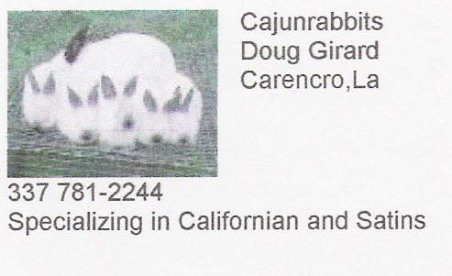


Easy Rabbit Farm
Eric & Gwen Himel
12304 Beco Road
St. Amant, LA 70774
225-647-1723
gwenhimel@yahoo.com

Black Satins, Dutch and
Black Havanas

ARBA, LRBA, ADRC,
ASRBA, BTRC, TPDC
& QCRBA Member

MEMBER ARBA JUDGES AND REGISTRARS
Liane Baird (R) |  | J.L. Dino (J) |  | Tom Green (J) |  | William Rome (J)
8866 Blanchard Furrh |  | 9134 Hwy 165 |  | 538 Phin Croft Rd |  | 312 Corsair Dr.
Shreveport LA 71107 |  | Pollock LA 71467-3508 |  | Marion KY 42064 |  | Baton Rouge, LA 70810
318.929.9149 |  | 318.765.8080 |  | 270.965.4150 |  | 225.752.8462
jlianehi@bellsouth.net |  | RJudgeDino635@aol.com |  | HarleTom@aol.com
Susan Borden (R) |  | Judy Duthu (R) |  | Guy Leger (retired)
315 Hwy 108 West |  | 600 Aragon Rd. |  | 3701 Heard Rd. |  | Floyd & Charmaine Rudolph
Sulphur LA 70663 |  | Montegut LA 70377 |  | Lake Charles, LA 70605 |  | 8577 Big Oak Dr.
337.583.9361 |  | 985.594.9551 |  | 337.447.3747 |  | Meridian MS 39305
suebord@camtel.com |  | ladutch@internet8.net |  |  |  | 601.679.9794
 |  |  |  | Lori Neagle (J) |  | cdargent@aol.com
Jimmie Daniel (R) |  | Frank Farrow (J) |  | 100 Baker St. |  | rabitgrl@aol.com
105 Dickie St. |  | 12868 FM 58 |  | Broussard LA 70518
Franklin LA 70538 |  | Lufkin TX 75901 |  | LNeagle@hotmail.com |  | Bruce Spillers (R)
337.828.0648 |  | 936.829.5040 |  |  |  | PO Box 64
jjdaniel@cox.net |  |  |  | Josh Humphries (J) |  | Choudrant, LA 71227
 |  |  |  | 7700 Runyon Rd |  | 318.251.2442
Lance Gendron (R) |  | Tracey Freeman (R) |  | Georgetown TN 37336 |  | bsfarms@bayou.com
1744 Frisco Dr. |  | 126 TNT’s Place |  | 423.344.3336
LaPlace LA 70068 |  | Bogalusa LA 70427 |  | frenchlops@juno.com
504.228.4165 |  | 985.732.5060
lgen0290@yahoo.com |  | tntcountrycritters@hotmail.com
LOUISIANA RABBIT BREEDERS ASSOCIATION, INC.
MEMBERSHIP APPLICATION
NAME:
ADDRESS:
PHONE # |  |  |  | E-MAIL
YOUTH $8.00 ( ) |  | INDIVIDUAL $12.00 ( ) |  | COMBO $20.00 ( )
YOUTH 3YRS $20.00 ( ) |  | INDIVIDUAL 3YRS $30.00( ) |  | COMBO 3YRS $50.00 ( )
FAMILY ($16.00 + $2.00 PER YOUTH) ( ) 3YR ($45 + $5 PER YOUTH) ( )
AGE & NAME OF YOUTH MEMBERS
RABBITRY NAME (ADDTL $1.00 PER YR)
NEWSLETTER MAILING PREFERENCE E-MAIL ( ) REGULAR MAIL ( )
CURRENT BREEDS
LOCAL LOUISIANA CLUB
 |  | (MUST FILL IN IF OUT-OF-STATE MEMBER COMPETING FOR SWEEPSTAKES POINTS)
REFERRED BY
Mail to: |  | Lori Neagle
 |  | 100 Baker St.
 |  | Broussard LA 70518

